Q1
#include &lt;stdio.h&gt;

int main() {
int a[5]={1,2,3,4,5};
int n=0;
int temp;

for(int j=0;j&lt;5;j++){

temp=a[n];
a[n]=a[n+4];
a[n+4]=temp;
}
for(int i=0;i&lt;5;i++){
printf(&quot;%d &quot;,a[i]);

}

return 0;
}
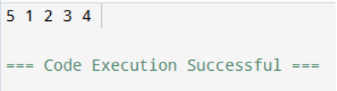

Q5
#include <stdio.h>

int main() {
int a[50],k;
int max, min;
printf("Enter size: ");
scanf("%d",&k);
printf("Enter elements:\n");
for(int i=0;i<k;i++)
scanf("%d",&a[i]);
max = min = a[0];

for(int i=1;i<k;i++) {
if(a[i] > max)
max = a[i];

if(a[i] < min)
min = a[i];
}

printf("Difference: %d", max - min);
}
return 0;
}
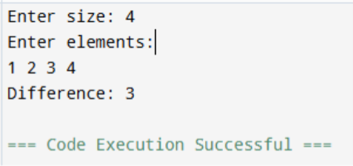
Q8
#include <stdio.h>

int main() {
char str[100];
printf("Enter a string = ");
scanf("%[^A-Za-z]", str);
printf("You entered: %s\n", str);
scanf("%s",str);
return 0;
}
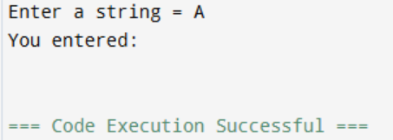
Q7#include <stdio.h>

int main()
{
int arr[10];
int i, j;

printf("Enter 10 numbers:\n");

for(i = 0; i < 10; i++)
scanf("%d", &arr[i]);

for(i = 0; i < 10; i++)
{
for(j = i + 1; j < 10; j++)
{
if(arr[i] == arr[j])
{
arr[j] = -1;
}
}
}

printf("Updated Array:\n");

for(i = 0; i < 10; i++)
printf("%d ", arr[i]);

return 0;
}
Q2
#include <stdio.h>

int main() {

int a[100], k, search, j;

printf("Enter number of elements: ");

scanf("%d", &k);

printf("Enter elements:\n");

for(int i=0; i<k; i++)

scanf("%d", &a[i]);

printf("Enter element to search: ");

scanf("%d", &search);

for(int i=0; i<k; i++) {

if(a[i] == search) {

printf("Element found at index %d", i);

}

}

}
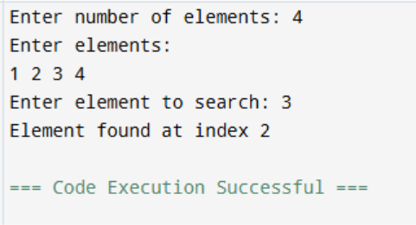
Q3
#include <stdio.h>

int main()
{
int pass[10], fail[10];
int i = 0, p = 0, f = 0;
int mark;
float avgPass = 0, avgFail = 0;

printf("Enter quiz marks :\n");

while(i < 10)
{
scanf("%d", &mark);

if(mark == -1)
break;

if(mark >= 5 && mark <= 10)
{
pass[p++] = mark;
avgPass += mark;
}
else if(mark >= 0 && mark < 5)
{
fail[f++] = mark;
avgFail += mark;
}

i++;
}

printf("\nPass Students Marks:\n");
for(i = 0; i < p; i++)
printf("%d ", pass[i]);

if(p > 0)
printf("\nAverage Pass Marks = %.2f\n", avgPass/p);

printf("\nFail Students Marks:\n");
for(i = 0; i < f; i++)
printf("%d ", fail[i]);

if(f > 0)
printf("\nAverage Fail Marks = %.2f\n", avgFail/f);

return 0;
}
Q4
#include <stdio.h>

int main()
{
char str[100];
int i = 0;

printf("Enter a sentence:\n");
scanf("%[^\n]", str);

while(str[i] != '\0')
{
if(str[i] >= 'a' && str[i] <= 'z')
str[i] = str[i] - 32;
else if(str[i] >= 'A' && str[i] <= 'Z')
str[i] = str[i] + 32;

i++;
}

printf("Converted message: %s", str);

return 0;
}
Q6
#include <stdio.h>

int main()
{
char str[100];
int i = 0, vowels = 0, consonants = 0;

printf("Enter a word: ");
scanf("%s", str);

while(str[i] != '\0')
{
if(str[i]=='a'||str[i]=='e'||str[i]=='i'||str[i]=='o'||str[i]=='u'||
str[i]=='A'||str[i]=='E'||str[i]=='I'||str[i]=='O'||str[i]=='U')
{
vowels++;
}
else
{
consonants++;
}

i++;
}

printf("Vowels = %d\n", vowels);
printf("Consonants = %d\n", consonants);

return 0;
}

